

**UV Beads**

## Overview:

Students will understand how nanostructures can interact with UV light. Students will obtain a general understanding of the electromagnetic spectrum and understand how both mineral-based sunscreen and UV beads use the same technology.

## Essential Questions:

How does UV light interact with the nanostructures in UV beads to make them change color? How does this process relate to mineral-based sunscreen?

## Goals:

Students will:

* Goal 1: Students will be able to identify one way light interacts with nanostructures.
* Goal 2: Students will perform their own experiment involving UV beads and sunscreen.
* Goal 3: Students will learn how scientists can utilize nanostructures to make sunscreen that is better for the environment.
* Goal 4: Students will see an example of how small structures can have a large impact.

## Research Connection:

Understanding how light interacts with nanostructures is important, both in designing materials with desired properties, and to characterize (or see) how these tiny, nanoscale structures impact macroscopic properties.

## Safety:

Do not shine UV flashlights directly into someone’s eyes.

## Materials / Preparation:

* Lab notebook
* Pen or pencil
* UV beads
* String
* Scissors
* Access to the sun and/or UV flashlights
* Zipbloc bag
* Sunscreen (preferably with different SPF values)

## Introduction:

1. Most sunscreens use chemical reactions to absorb UV light from the sun once it penetrates your skin. This chemical reaction converts UV light to heat, which gets absorbed and then released by your skin. **Oxybenzone** is the most common UV converting chemical in sunscreen.
2. Oxybenzone has been linked to bleaching in coral reefs. In general, chemical sunscreen is extremely harmful to reefs and sea life. In fact, in July of 2018, Hawaii banned banned the sale of sunscreens containing oxybenzone and octinoxate, a law that went into effect on January 1, 2021.

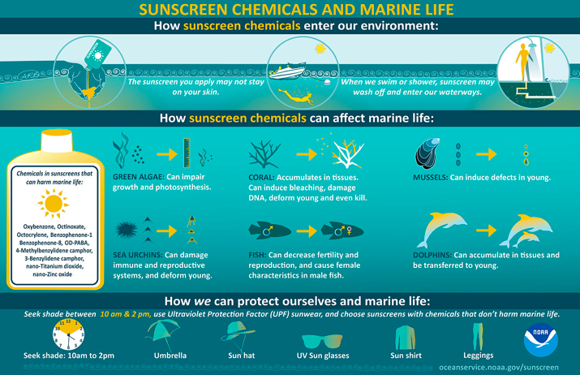

1. Replacing chemical absorption with structural absorption (can) reduce toxicity. Some types of sunscreen are mineral-based, meaning they use either zinc oxide or titanium dioxide minerals to block the sun from even penetrating into your skin.[1] This technology is the same as UV beads! However, minerals that are smaller than 100 nanometers are equivalently bad for reefs because coral can ingest the nanoparticles.[2] Moreover, titanium dioxide (another sunscreen ingredient) does not biodegrade and is found to react in warm seawater to form hydrogen peroxide, which is harmful to all sea life.[3] Instead, the best "reef-friendly" sunscreens are mineral-based that use micrometer-sized zinc oxide particles (or non-nano minerals).
2. Side note: Scientists also made beads of iron oxide nanoparticles in non-toxic minerals to absorb oxybenzone in ocean water. [4]

## Main Activity:

* + - 1. Have students make a bracelet using the UV beads and string for them to keep.
      2. Have students plan their own experiment to test how sunscreen affects UV exposure using some UV beads
         1. Remind students that a control group is necessary for almost all experiments. A control group is defined as the standard to which comparisons are made in an experiment.
         2. Have students write down their experiment in their lab notebooks.
         3. Have students identify a good control group (no sunscreen).
         4. Put a few UV bead inside a Ziploc bag. Rub sunscreen (with various SPFs) over Ziploc bag. Set bag in sun (or shine UV flashlight) and wait a few minutes.
         5. The UV beads with sunscreen should appear less bright but should still change color.

## Post Activity Questions:

Did any group of beads not change color? Why do you think that is?

Are there other ways you could limit UV exposure to the beads?

**Extensions:**

To help students further explore these concepts, consider the following extensions to either the activity or lesson plan.

1. UV beads contain nanoparticles that change shape in UV light. The new shape then allows them to emit visible light when they absorb heat and shift back into their preferred non-excited state. One formulation is shown below, where UV light breaks an oxygen-to-carbon bond and expands the shape of the nanoparticle.

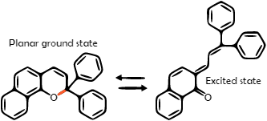

1. Test different sources of UV light (flashlight, sunlight, incandescent bulb, LED bulb, blacklight).
2. Take pictures of beads using a DSLR and use brightness or other value to quantify the brightness of the beads.

## Resources and References:

[1] <https://savethereef.org/about-reef-save-sunscreen.html>

[2] <https://www.rei.com/learn/expert-advice/what-is-reef-safe-sunscreen.html>

[3] <https://www.hawaii.com/travel-info/reef-safe-sunscreen/>

[4] <https://www.chemistryworld.com/news/magnetic-beads-mop-up-sunblock-in-the-sea/3007881.article>